LINUX COMMANDS EXECUTION
- Identifying directory and file
File – Initially it represents ‘-‘
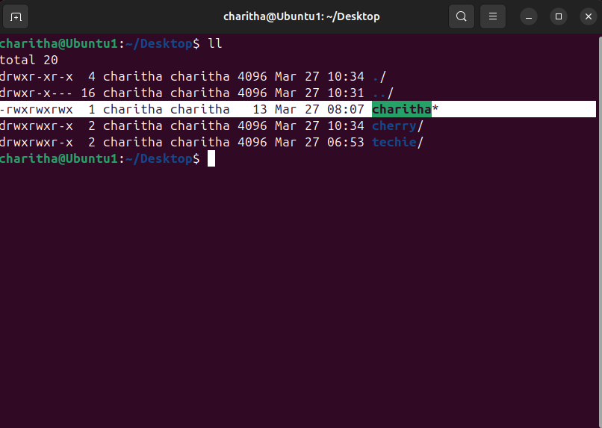
- Directry- Initially it represents ‘d’
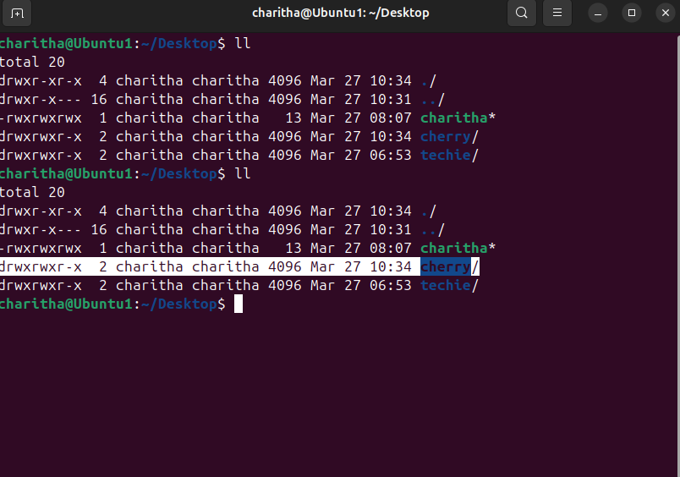

chmod 777 - To modify the access and permission
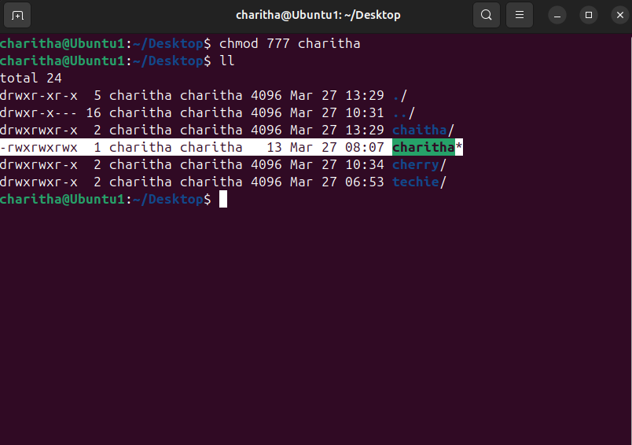
User should have read access, group should have read, write and execute access and others should have execute access. What should be the permissions ?
- chmod 471

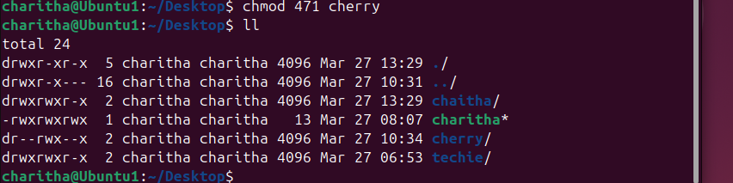

- cat /etc/passwd – To check the list of users in the virtual machine
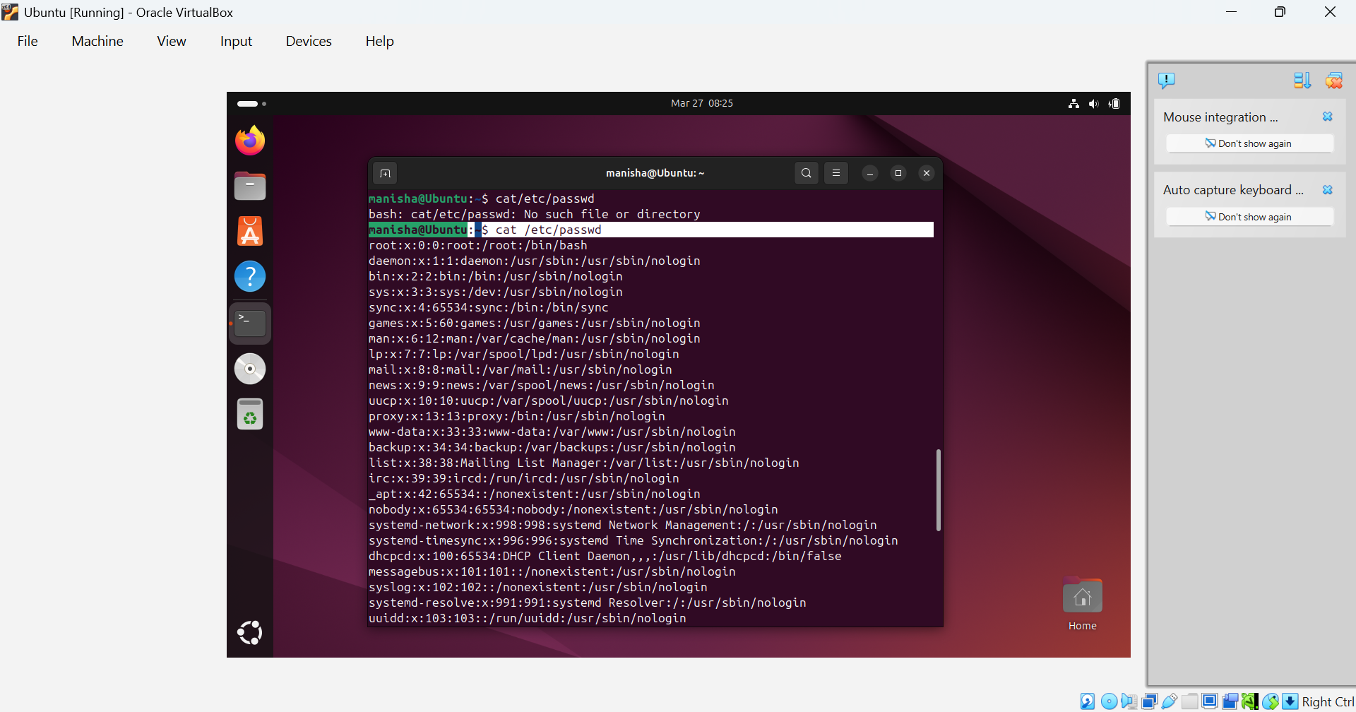

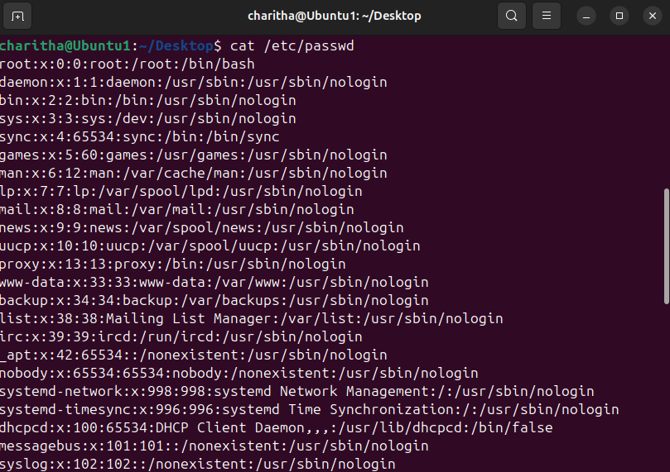
- chown – change ownership

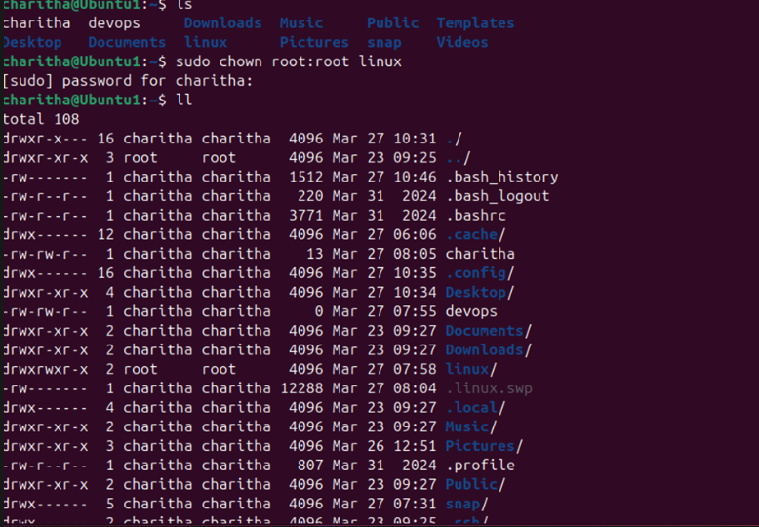

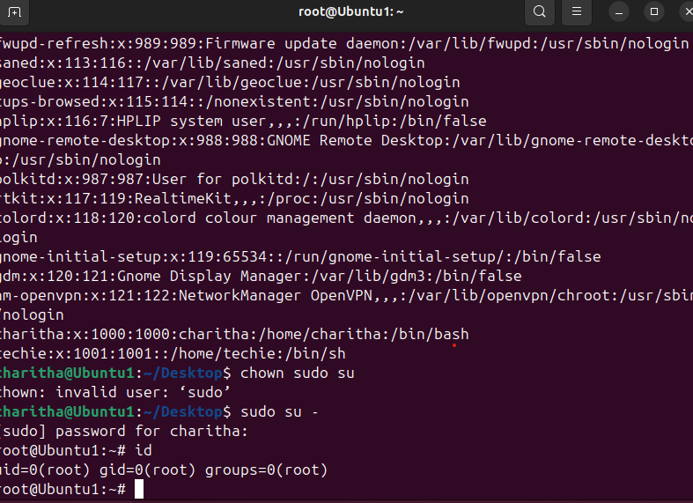
- sudosu – Switch user
- useradd – to create user
- passwd- to create password
- cat /etc/passwd – to check the user

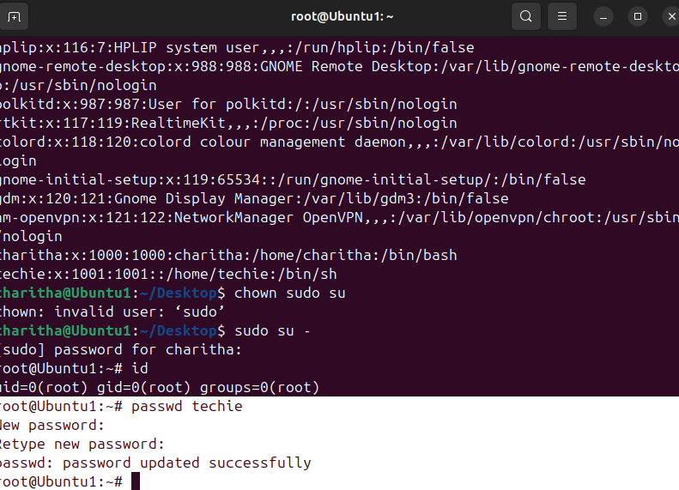

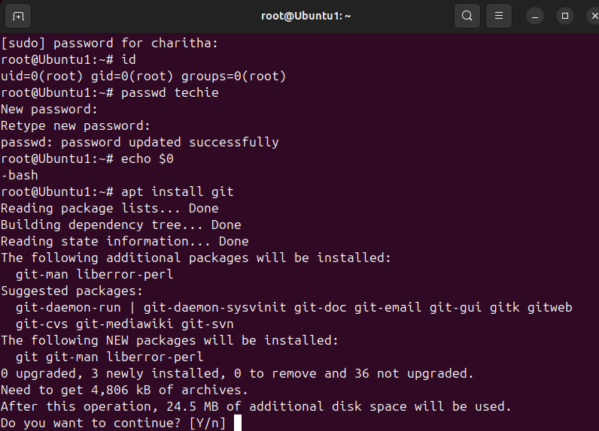
- find /-name sudoers – To check the sudoers file
- cat / etc/sudoers – To check all the sudoers
- vi / etc/sudoers- where we can give permissions

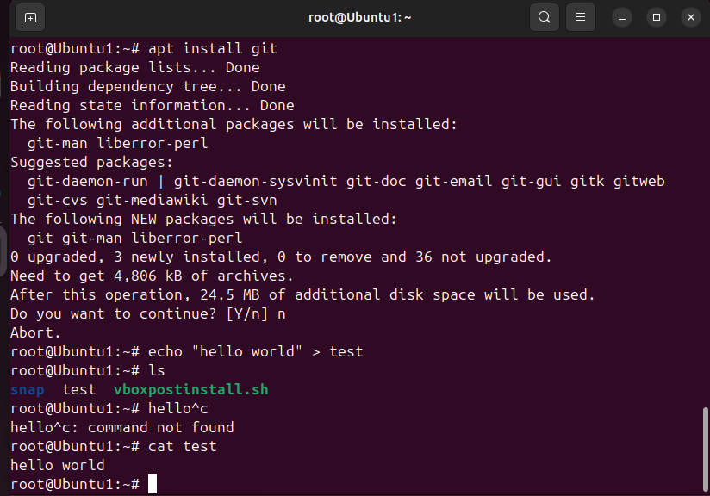
- Echo – it displays the given input as a output.
- echo “ world” – it prints world
- echo “world” > test – it means we are saving as a file
- Head -3 - To read the first 3 lines of command
- Tail -3 - To read last 4 lines of command

